BMS lowervoltage fault

Author: 胡心怡
Reviewer:Eason

FAQ\BAT
Issue introduction
The inverter screen displays “BMS_Lower Voltage”
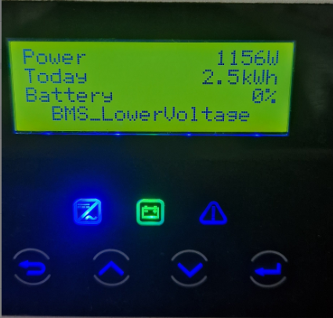
Confirmation of basic information
[Photo]SN number of the inverter and battery.
Collect the historical alarm to check the occurrence count and frequency.
Guidance for installer
Step1: Measure the voltage of each battery.
Measure the voltage of T58 | Measure the voltage of T30
Use the red pen and black pen of the multimeter to measure whether the voltage on the battery side is normal.Normal single T58 battery has a rated voltage of 115.2V, the operating voltage range of 100-131V.  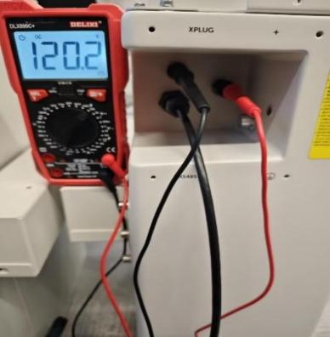 | Use the same method to measure the voltage of T30, insert the pen into the round hole to the right of the terminal. A normal T30 single battery has a rated voltage value of 102.4V and the operating voltage range of 90-116V.  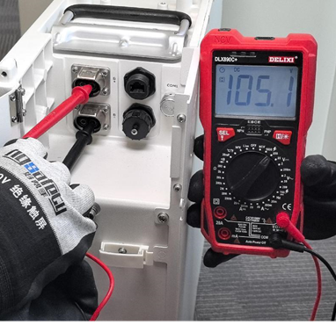
Step2：If the voltage of each battery is above 40V and the total system battery voltage meets the inverter's minimum battery voltage requirement, use the inverter's force charging mode to recharge the batteries.
Setting path: Work mode→Work mode→Manual→Force charge
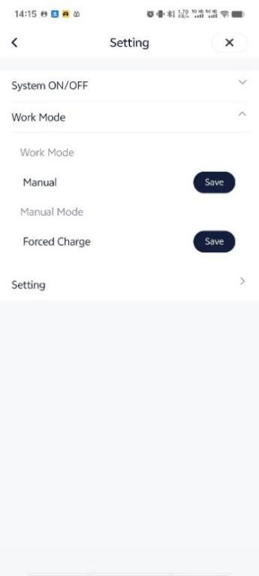
If the inverter is unable to complete force charging, and the voltage of a single battery is already below 40V, please refer to the attached T-BAT Charger user manual to perform forced charging on the battery.
https://km.solaxpower.com/index.html#doc/enterprise/362472
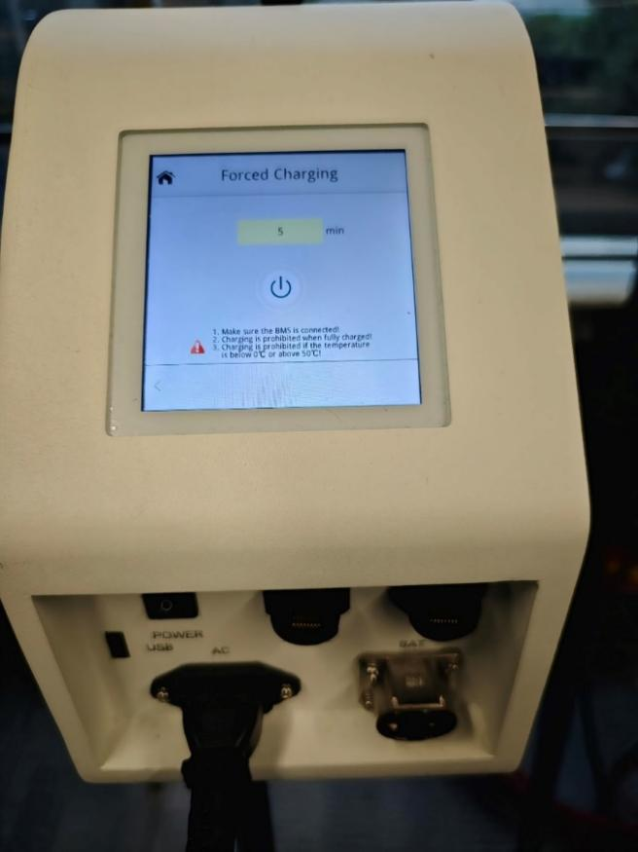
Step3: Check the status indicators of batteries.
For T58, in the normal state, the Master status indicators are always green and the slaves flash green every five seconds.
Status indicators of T58 BMS | Status indicators of T58
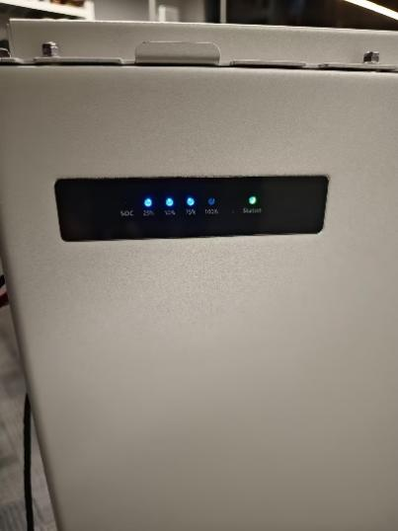 | 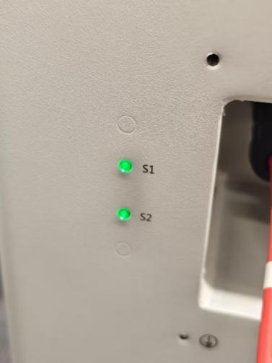
For T30, the BMS status indicators are always green and the slaves flash green every five seconds.
Status indicators of T30 BMS | Status indicators of T30 slave
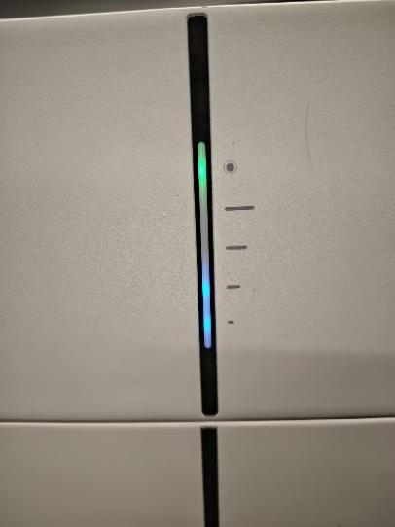 | 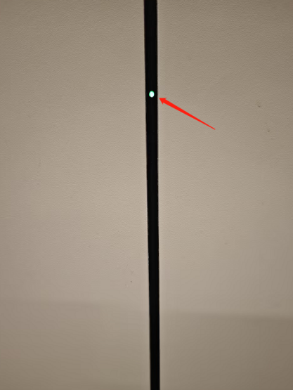
If the status indicators of the slave are abnormal, remove it then connect other batteries and start the system to see whether the error is reported.
Information check list
If you have completed the above <Guidance for installer>, and the problem is still not solved, please collect the following troubleshooting information and send them to the R&D.
1. [Photo]SN number of the inverter and batteries.
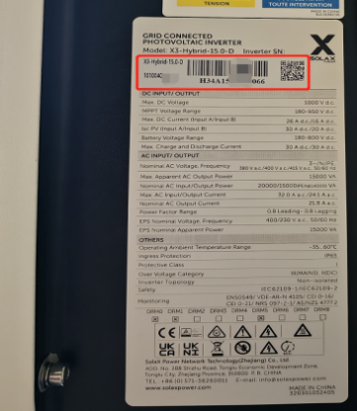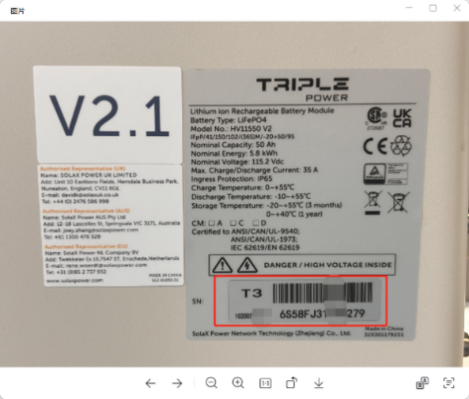
2. [Photo]The voltage of each battery.
Measure the voltage of T58 | Measure the voltage of T30
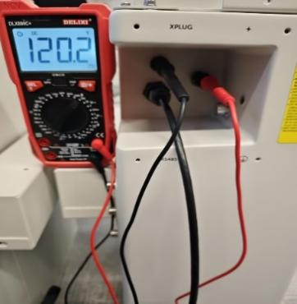 | 
3. [Video]Scintillation mode of status indicator.

